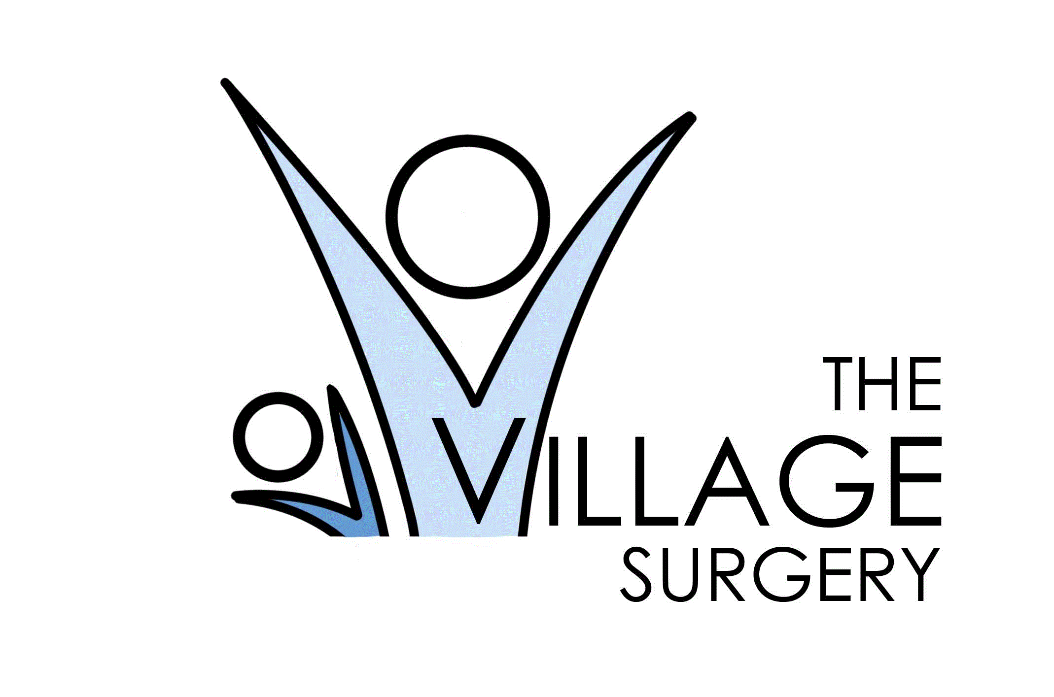 Patient Newsletter September 2025

**💉 2025/26 Flu Vaccination Campaign – Book Now!**

We’re holding a **Saturday Flu Clinic** on:  
📅 **Saturday 4th October 2025**  
📍 **Village Surgery**

This clinic is for:

* Patients **aged 65 and over**
* Patients **at higher risk** (long-term conditions, weakened immunity, or as advised by a clinician)

**Important Information**

* A **self-booking link** is being sent out to all eligible patients.
* **Limited vaccinations are available** – once clinics are full, they are full.
* Clinics are **filling fast**, so please book as soon as you receive your link

Thank you for helping us keep our community healthy this winter.

**🗣️ Your Voice Matters – Help Us Improve Village Surgery**

At Village Surgery, we believe the best way to improve our services is by listening to the people who use them – you, our patients.

That’s why we have launched our **“Your Voice Matters”** campaign.

Why your feedback is important:

* ✅ It helps us understand what we’re doing well
* ✅ It highlights areas where we can do better
* ✅ It shapes future services to meet the needs of our community

We want every patient to feel heard. Your experiences, suggestions, and ideas will directly influence how we provide care now and in the future.

How you can get involved:

* Complete Friend & Family feedback (through our website)
* Take part in patient surveys
* Share your views with our Patient Participation Group (PPG)

Together, we can make Village Surgery the very best it can be.

**👉 Your Voice Matters – let it be heard!**

**Stay Connected with the NHS App**

Did you know you can now manage your healthcare quickly and securely through the NHS App?

With the app you can:

✔️ Book and manage appointments

✔️ Order repeat prescriptions

✔️ View your test results

✔️ Check your vaccination record

✔️ Access your medical record securely

✔️ Receive important messages from the practice

The NHS App is free, safe, and available to download on any smartphone or tablet.  
👉 Search for **“NHS App”** in your app store.

Take control of your healthcare today – it’s simple, quick, and always at your fingertips.

**👧🧒 CYP Vaccination Campaign – Protecting Our Children**

Keeping children healthy is one of the best ways we can protect our community. That’s why vaccination is so important.

**Why get vaccinated?**

* ✅ **Protects your child** – vaccines help prevent serious illness
* ✅ **Protects others** – reduces the spread of infections to family, friends, and the wider community
* ✅ **Protects the future** – helps keep schools, clubs, and activities running smoothly

Vaccines are safe, effective, and one of the best ways to give children a healthy start in life.

If your child is eligible for vaccination, please take up the invitation when it arrives. Together, we can keep our children and community safe.

👉 **Your child’s health matters – please say yes to vaccination.**

**Practice Website**

We encourage all our patients to regularly visit our **Practice Website** for the **latest news and updates** about our services, clinics, and health campaigns.

Don’t forget to check out our **Patient Zone page**, where you’ll find:

* Helpful links to trusted national health resources
* Information about local support services and community groups
* Guidance to help you manage your health and wellbeing

👉 Visit us online today to stay connected and informed.

<https://www.villagesurgeryderby.org.uk/>

**❌ Missed Appointments – Why It Matters**

When patients don’t attend (DNA) appointments and don’t cancel, valuable time is lost.

This means:

* Longer waits for others
* Wasted clinical resources

**Why we publish DNA data**

We share this information to show the impact and encourage everyone to work together to reduce wasted appointments.

How you can help

If you can’t attend, please cancel early – online, through the NHS App, or by calling reception.

👉 **Every cancelled appointment helps another patient get seen.**

**Follow us on Facebook!! @VillageSurgeryDerby**

**Please follow us for regular updates and Surgery news**

**DNA Data – August 2025**

Over the month of August, we had **135** missed appointments, that means 135 patients could have been seen at Village Surgery!

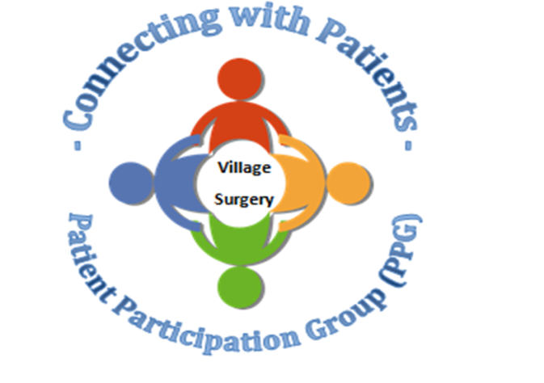

**Closed Dates**

Staff training

* Wednesday 17th September from 1.30pm
* Wednesday 15th October from 1.30pm
* Wednesday 19th November from 1.30pm

Christmas & New Year Bank Holidays

* Thursday 25th December
* Friday 26th December
* Thursday 1st January

During these times 111 or the walk-in centre are available for urgent medical attention. Or call 999 for life-threatening emergencies.

Relias training

There is still a lot of online training outstanding. Please complete as soon as possible.

<https://villagesurgeryderby.training.relias.co.uk>

[If you are unsure of your log on details let Claire or Lauren know.](https://villagesurgeryderby.training.relias.co.uk)

Autumn 2019

Autumn 2019

Upcoming Quest Sessions

• 20th November 2019—we are hoping to do a ‘scenario’ afternoon. As emergency situations are an ‘emergency’ we don’t get to practice before they happen. This will be an opportunity for staff to practice these emergency situations and also to highlight areas that need attention.

• 18th December 2019—Christmas fuddle. We will be having a fun Christmas afternoon, exchanging secret Santa gifts, eating food and playing games.